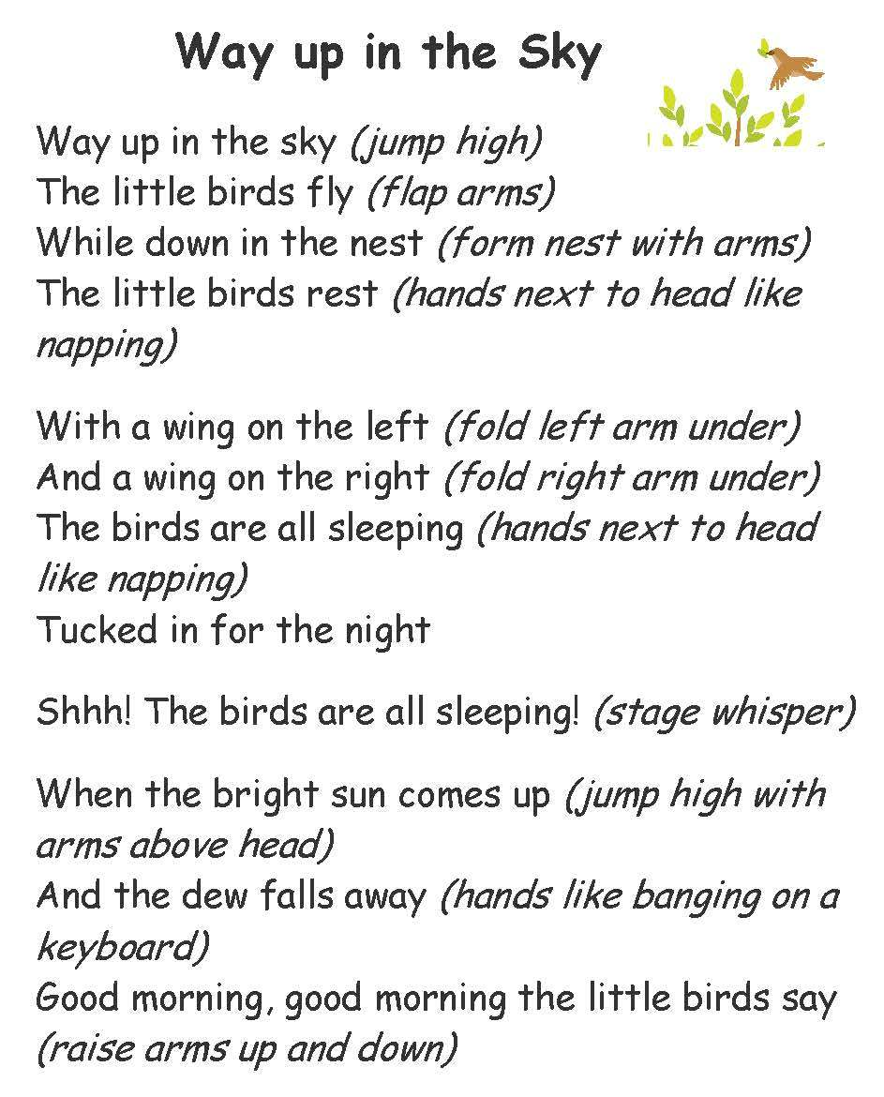

‘

One, Two Caribou From Northern Rhymes – NWT Literacy Council

One, two
Caribou.

Three, four
Fishing from shore.

Five, six
Fire by sticks.

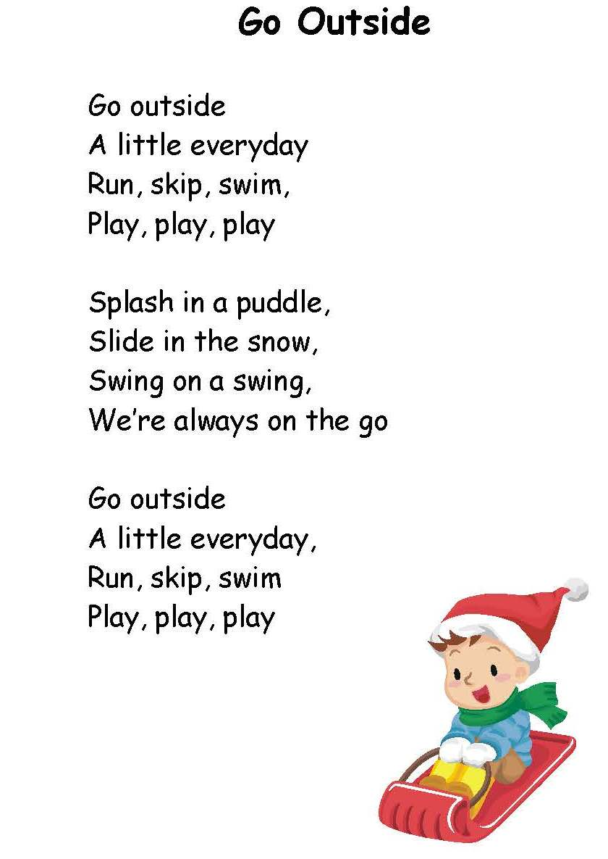
Seven, eight
Bannock we make.

Nine, ten
Camping again!

