An Introduction to Land Art

# What is Land Art?

chara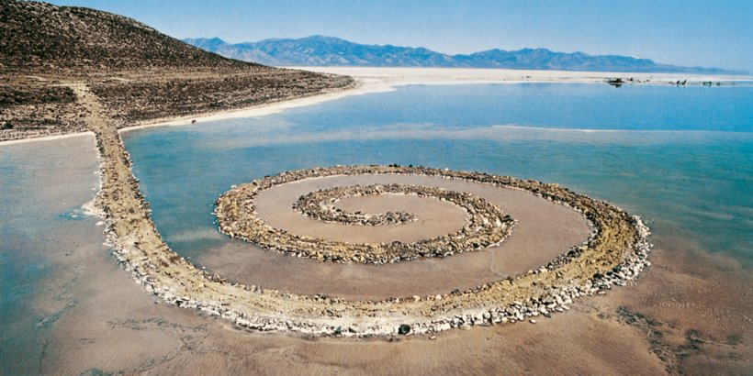

Spiral Jetty by Robert Smithson, 1970

In the 1950’s and 60’s the contemporary visual art world was awash with [Art Superstars](http://en.wikipedia.org/wiki/Andy_Warhol). Galleries were full of million dollar [minimalist](http://en.wikipedia.org/wiki/Minimalism), [abstract impressionist](http://www.abstractimpressionism.com/abstract-impressionism.html), and [pop art](http://www.moma.org/collection/details.php?theme_id=10170) works. Visual art had become the domain of the wealthy. In response to this the 70’s brought the birth of [Arte Povera](http://en.wikipedia.org/wiki/Arte_Povera), which championed artworks made of everyday objects and [Land or Environmental Art](http://en.wikipedia.org/wiki/Land_art).

[Land Art](http://www.saylor.org/site/wp-content/uploads/2011/05/Land-Art.pdf) challenged the idea that art belonged in galleries and existed for the purpose of being bought by a collector. Most [Land Art](http://www.wikilinks.fr/selection-de-land-art/) exists outdoors and interacts with the environment in a way that means it is temporary or ephemeral. Probably the most famous, and one of the first, pieces of land art is [Spiral Jetty by Robert Smithson](http://www.robertsmithson.com/earthworks/spiral_jetty.htm). Over the years since it was built it has twice been submerged under the water as the water levels raised and reappeared once it receded.

During the economic downturn large Earthworks like Spiral Jetty or [Christo’s](http://www.christojeanneclaude.net/) wrapped objects died out due to a lack of funds. Today there is a resurgence of Land Art inspired by Arte Povera that uses objects found in Nature to create site specific artworks. Artists like South African [Strijdom van der Merwe](http://en.wikipedia.org/wiki/Strijdom_van_der_Merwe) and [Andy Goldsworthy](http://www.morning-earth.org/ARTISTNATURALISTS/AN_Goldsworthy.html) have revived what looked to be a lost art form.

Today we see land art being adopted by purveyors of [Forest Schools](http://www.forestschoolcanada.ca/) and other members of what Richard Louv calls the New Nature Movement. [Richard Shilling](http://en.wikipedia.org/wiki/Richard_Shilling) and Julia Brooklyn have published a book about doing [Land Art with Children](http://www.richardshilling.co.uk/section331742_149027.html). [Clay faces](http://visitwoods.org.uk/en/visit-woods/things-to-do/adventure/Documents/Nature-Detectives-Boggarts.pdf) on trees, [yarn bombing](http://www.yarnbomber.com/uploads/2/2/4/9/22494536/santa_barbara_news-press.pdf), [guerilla gardening](http://www.guerrillagardening.org/ggtroopdigs.html) and [Mandala’s](https://www.youtube.com/watch?v=OE4SnUyoEDQ) made with natural objects are all over pinterest and other social media.

**Land Artists to look up:**

[Nils Udo](http://www.morning-earth.org/ARTISTNATURALISTS/AN_Nils_Udo.html), [Chris Drury](http://chrisdrury.co.uk/), [Jean-Yves Piffard](http://www.piffard.ch/), [Marie-Sophie Koulisher](http://www.msdk.fr/)